WEEK 8 OS LAB

1BM21CS247

**Write a C program to simulate disk scheduling algorithms**  
  
a)  FCFS  
b)    SCAN  
c)  C-SCAN

SOURCE CODE:-

#include <stdio.h>

#include <stdlib.h>

#define MAX_REQUESTS 100

void fcfs(int requests[], int n, int start) {

int totalSeek = 0, current = start;

printf("FCFS Disk Scheduling:\n");

for (int i = 0; i < n; i++) {

totalSeek += abs(current - requests[i]);

printf("Move from %d to %d\n", current, requests[i]);

current = requests[i];

}

printf("Total Seek Distance: %d\n", totalSeek);

}

void scan(int requests[], int n, int start, int maxCylinder) {

int totalSeek = 0, current = start;

printf("SCAN Disk Scheduling:\n");

int direction = 1; // 1 for right, -1 for left

int maxIndex = (direction == 1) ? maxCylinder : 0;

for (int i = 0; i < n; i++) {

totalSeek += abs(current - requests[i]);

printf("Move from %d to %d\n", current, requests[i]);

current = requests[i];

}

totalSeek += abs(current - maxIndex);

printf("Move from %d to %d\n", current, maxIndex);

for (int i = n - 1; i >= 0; i--) {

totalSeek += abs(maxIndex - requests[i]);

printf("Move from %d to %d\n", maxIndex, requests[i]);

maxIndex = requests[i];

}

printf("Total Seek Distance: %d\n", totalSeek);

}

void cScan(int requests[], int n, int start, int maxCylinder) {

int totalSeek = 0, current = start;

printf("C-SCAN Disk Scheduling:\n");

int maxIndex = maxCylinder;

for (int i = 0; i < n; i++) {

totalSeek += abs(current - requests[i]);

printf("Move from %d to %d\n", current, requests[i]);

current = requests[i];

}

totalSeek += abs(current - maxIndex);

printf("Move from %d to %d\n", current, maxIndex);

current = 0;

for (int i = 0; i < n; i++) {

totalSeek += abs(current - requests[i]);

printf("Move from %d to %d\n", current, requests[i]);

current = requests[i];

}

printf("Total Seek Distance: %d\n", totalSeek);

}

int main() {

int requests[MAX_REQUESTS], n, start, maxCylinder;

printf("Enter the number of requests: ");

scanf("%d", &n);

if (n > MAX_REQUESTS) {

printf("Maximum number of requests exceeded.\n");

return 1;

}

printf("Enter the requests: ");

for (int i = 0; i < n; i++)

scanf("%d", &requests[i]);

printf("Enter the starting position: ");

scanf("%d", &start);

printf("Enter the maximum cylinder value: ");

scanf("%d", &maxCylinder);

fcfs(requests, n, start);

scan(requests, n, start, maxCylinder);

cScan(requests, n, start, maxCylinder);

return 0;

}

OUTPUT:-

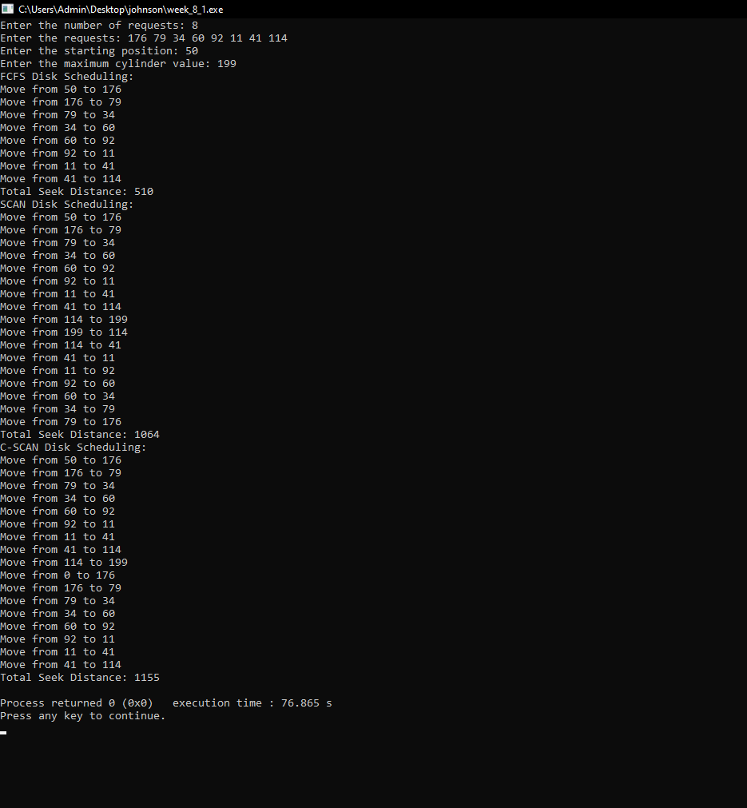

**Write a C program to simulate disk scheduling algorithms**  
  
a)    SSTF  
b)  LOOK  
c)  c-LOOK

Source code:-

#include <stdio.h>

#include <stdlib.h>

#define MAX_REQUESTS 100

void sort(int arr[], int n) {

for (int i = 0; i < n - 1; i++)

for (int j = 0; j < n - i - 1; j++)

if (arr[j] > arr[j + 1])

arr[j] ^= arr[j + 1] ^= arr[j] ^= arr[j + 1];

}

int absDiff(int a, int b) {

return (a > b) ? a - b : b - a;

}

void sstf(int requests[], int n, int start) {

int totalSeek = 0, current = start, visited[MAX_REQUESTS] = {0};

printf("SSTF Disk Scheduling:\n");

for (int i = 0; i < n; i++) {

int minDist = __INT_MAX__, nextIndex = -1;

for (int j = 0; j < n; j++) {

if (!visited[j]) {

int distance = absDiff(current, requests[j]);

if (distance < minDist) {

minDist = distance;

nextIndex = j;

}

}

}

visited[nextIndex] = 1;

totalSeek += minDist;

printf("Move from %d to %d\n", current, requests[nextIndex]);

current = requests[nextIndex];

}

printf("Total Seek Distance: %d\n", totalSeek);

}

void look(int requests[], int n, int start, int direction) {

int totalSeek = 0, current = start;

sort(requests, n);

printf("LOOK Disk Scheduling:\n");

int i = (direction == 1) ? 0 : n - 1;

int end = (direction == 1) ? n : -1;

int step = (direction == 1) ? 1 : -1;

while (i != end) {

if (direction == 1 && requests[i] < current)

break;

if (direction == 0 && requests[i] > current)

break;

totalSeek += absDiff(current, requests[i]);

printf("Move from %d to %d\n", current, requests[i]);

current = requests[i];

i += step;

}

printf("Total Seek Distance: %d\n", totalSeek);

}

void cLook(int requests[], int n, int start) {

int totalSeek = 0, current = start;

sort(requests, n);

printf("C-LOOK Disk Scheduling:\n");

int index = 0;

while (index < n && requests[index] <= current)

index++;

for (int i = index; i < n; i++) {

totalSeek += absDiff(current, requests[i]);

printf("Move from %d to %d\n", current, requests[i]);

current = requests[i];

}

for (int i = 0; i < index; i++) {

totalSeek += absDiff(current, requests[i]);

printf("Move from %d to %d\n", current, requests[i]);

current = requests[i];

}

printf("Total Seek Distance: %d\n", totalSeek);

}

int main() {

int requests[MAX_REQUESTS], n, start, direction, choice;

printf("Enter the number of requests: ");

scanf("%d", &n);

if (n > MAX_REQUESTS) {

printf("Maximum number of requests exceeded.\n");

return 1;

}

printf("Enter the requests: ");

for (int i = 0; i < n; i++)

scanf("%d", &requests[i]);

printf("Enter the starting position: ");

scanf("%d", &start);

printf("Enter the direction (1 for upward, 0 for downward): ");

scanf("%d", &direction);

printf("Choose Disk Scheduling Algorithm:\n");

printf("1. SSTF\n2. LOOK\n3. C-LOOK\n");

scanf("%d", &choice);

switch (choice) {

case 1:

sstf(requests, n, start);

break;

case 2:

look(requests, n, start, direction);

break;

case 3:

cLook(requests, n, start);

break;

default:

printf("Invalid choice!\n");

break;

}

return 0;

}

OUTPUT:-

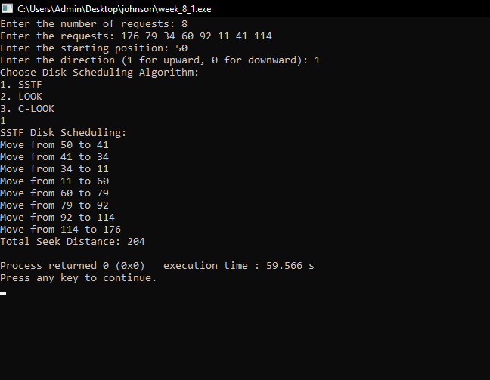

**Write a C program to simulate page replacement algorithms**  
a) FIFO  
b) LRU  
c)Optimal

SOURCE CODE:-

#include <stdio.h>

#define NUM_FRAMES 3

#define NUM_PAGES 10

void printFrames(int frames[]) {

for (int i = 0; i < NUM_FRAMES; i++)

printf("%2d ", frames[i]);

printf("\n");

}

int findIndex(int arr[], int n, int element) {

for (int i = 0; i < n; i++)

if (arr[i] == element)

return i;

return -1;

}

void fifo(int pages[]) {

int frames[NUM_FRAMES] = {0};

int frameIndex = 0, pageFaults = 0;

for (int i = 0; i < NUM_PAGES; i++) {

int page = pages[i];

if (findIndex(frames, NUM_FRAMES, page) == -1) {

frames[frameIndex] = page;

frameIndex = (frameIndex + 1) % NUM_FRAMES;

pageFaults++;

}

printf("Page %2d -> ", page);

printFrames(frames);

}

printf("FIFO Page Faults: %d\n", pageFaults);

}

void lru(int pages[]) {

int frames[NUM_FRAMES] = {0};

int pageFaults = 0;

for (int i = 0; i < NUM_PAGES; i++) {

int page = pages[i];

int index = findIndex(frames, NUM_FRAMES, page);

if (index == -1) {

for (int j = 0; j < NUM_FRAMES; j++)

if (frames[j] == 0 || findIndex(pages, i, frames[j]) == -1) {

frames[j] = page;

break;

}

pageFaults++;

}

printf("Page %2d -> ", page);

printFrames(frames);

}

printf("LRU Page Faults: %d\n", pageFaults);

}

void optimal(int pages[]) {

int frames[NUM_FRAMES] = {0};

int pageFaults = 0;

for (int i = 0; i < NUM_PAGES; i++) {

int page = pages[i];

int index = findIndex(frames, NUM_FRAMES, page);

if (index == -1) {

int optimalIndex = -1;

for (int j = 0; j < NUM_FRAMES; j++) {

int pageIndex = findIndex(pages, NUM_PAGES, frames[j]);

if (pageIndex == -1) {

optimalIndex = j;

break;

}

if (optimalIndex == -1 || pageIndex > findIndex(pages, NUM_PAGES, frames[optimalIndex]))

optimalIndex = j;

}

frames[optimalIndex] = page;

pageFaults++;

}

printf("Page %2d -> ", page);

printFrames(frames);

}

printf("Optimal Page Faults: %d\n", pageFaults);

}

int main() {

int pages[NUM_PAGES] = {2, 3, 2, 1, 5, 2, 4, 5, 3, 2};

printf("Page Reference Sequence: ");

for (int i = 0; i < NUM_PAGES; i++)

printf("%2d ", pages[i]);

printf("\n");

switch(ch)

{

case 1:

fifo(pages); break;

case 2:

lru(pages); break;

case 3:

optimal(pages); break;

case 4: exit(0); break;

default: printf("Invalid\n"); break;

}

return 0;

}

OUTPUT:-

